Deep Reinforcement Learning:
Deep Reinforcement Learning (DRL) combines deep learning with traditional reinforcement learning. Unlike supervised or unsupervised learning, DRL focuses on learning from interaction, with minimal or no human-provided labels. It is powerful for solving problems in robotics, autonomous driving, and games.

Learning Paradigms
Type | Description
Supervised Learning | Learns from input-output (X, Y) pairs (e.g., image classification).
Unsupervised Learning | Learns from data without labels (e.g., clustering, dimensionality reduction).
Reinforcement Learning | Learns by interacting with an environment to maximize cumulative rewards.

Key RL Terminology
Term | Description
Agent | The learner/decision-maker (e.g., a robot or self-driving car).
Environment | Everything outside the agent that it interacts with.
State (Observation) | Current representation of the environment.
Action | A choice the agent makes (e.g., move left or right).
Reward | Feedback signal indicating how good the action was.
Return | Total discounted sum of future rewards.

Return (𝑅ₜ) — Total Discounted Future Reward

Definition
The return at time t is denoted as:
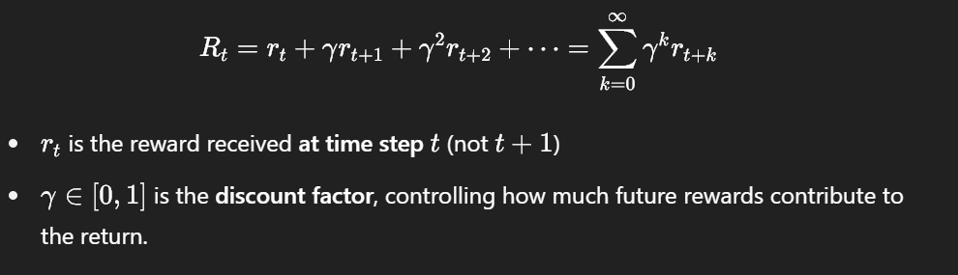

Key Concepts
Setting | Interpretation
γ=0 | Agent cares only about immediate reward.
γ≈1 | Agent considers long-term rewards more heavily.
γ<1 | Ensures convergence of infinite reward sums in long episodes.

Q-function Q(s,a)— Action-Value Function

Definition
The Q-function Q(s,a) represents the expected return when the agent is in state s, takes action a, and then follows a policy π:
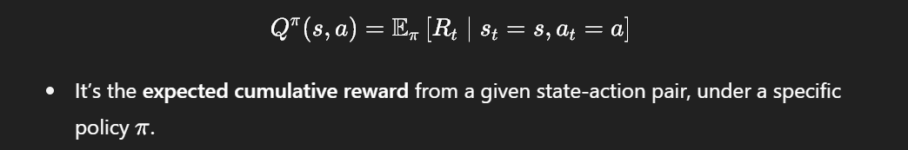

Optimal Q-function
The optimal Q-function Q∗(s,a) is defined as the maximum expected return achievable from s and a, across all policies:
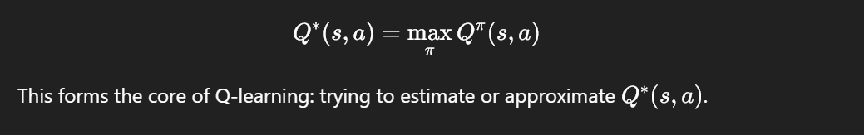

Action Selection Using Q
Once the agent learns Q(s,a), it can choose the best action in a state:
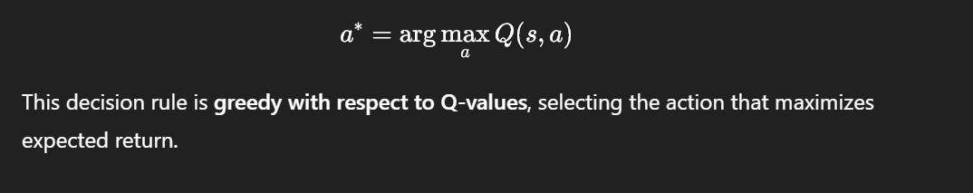

Why Q-functions Are Useful
- No need to model the full environment.
- They allow value-based decision making.
- Easily extended to deep Q-networks (DQN) by approximating Q(s,a) using a neural network.

Deep Q-Networks (DQN)

What is DQN?
DQN stands for Deep Q-Network, which is a value-based RL algorithm that uses a neural network to approximate the Q-function:
Q(s,a;θ) ≈ Expected return from (s,a)

Key Components
Component | Description
Input | State s (e.g., image frame from a game like Atari)
Output | Q-values for each possible discrete action Q(s,a)
Action | Select the action with the maximum Q-value
Loss Function | L=(Q(s,a)−target)^2

with target:
target=rt+γmaxQ(s′,a′;θ)
⁡a`
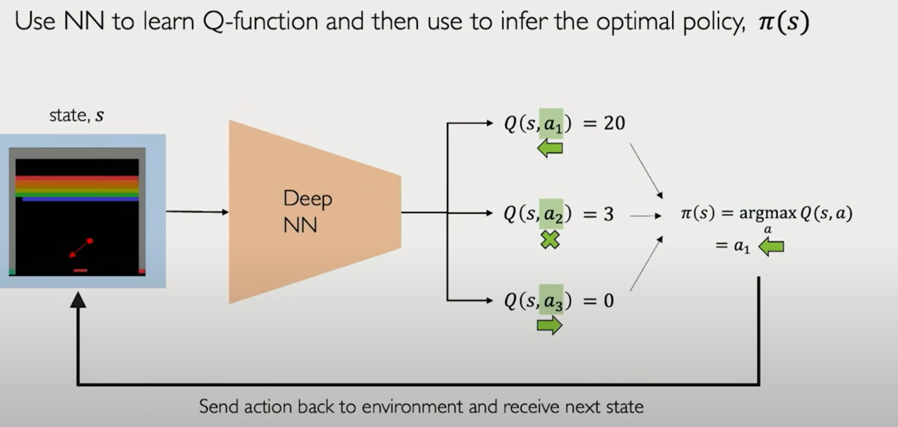

Limitations of DQN
- Works only for discrete action spaces.
- Can become unstable due to:
  - Correlated updates (sequential data)
  - Moving target (non-stationary target Q-values)

Solutions to Stabilize DQN
Technique | Purpose
Experience Replay | Store past experiences in a buffer and sample randomly to break correlations.
Target Networks | Maintain a separate, slowly updated target network to compute stable Q-targets.

Policy Gradient Methods

What Are Policy Gradient Methods?
Instead of estimating value functions (like Q(s,a)), policy gradient methods directly learn the policy itself — i.e.,
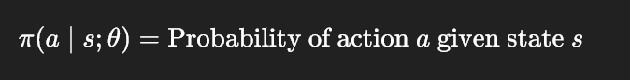
that maps a state to a probability distribution over actions.
In other words, the model tells you:
"Given this situation (state), what’s the probability I should take each possible action?"

Why Use Policy Gradients?

Good For:
- Continuous action spaces (like steering angles or robot joint velocities)
- Stochastic environments where randomness is part of the system
- Direct optimization of performance (returns) via gradient ascent
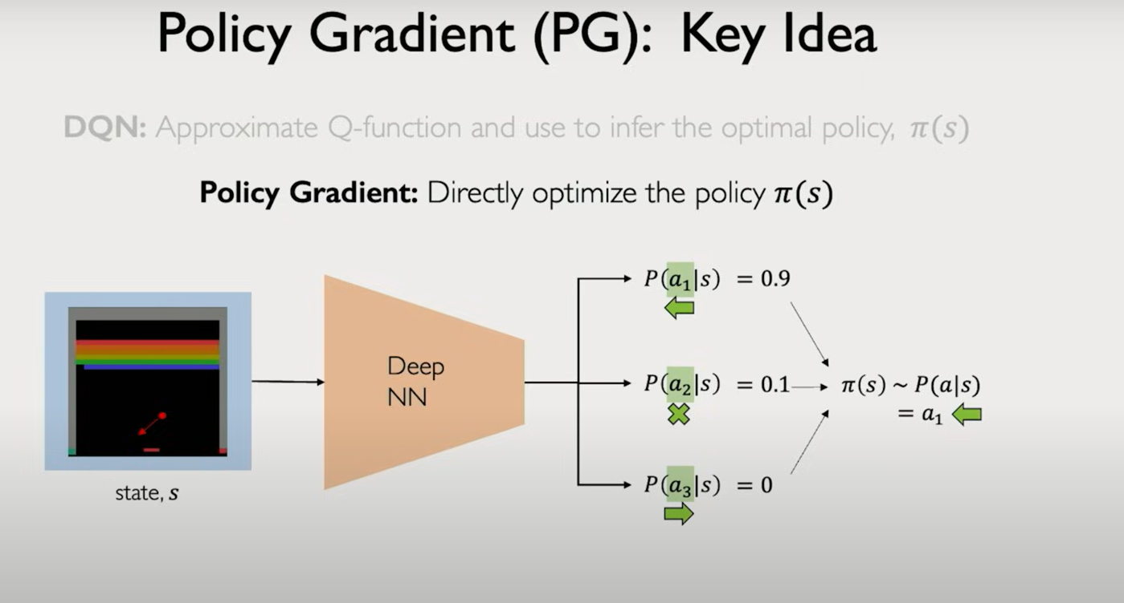

Policy vs. Value-based RL

Category | Value-Based (e.g., DQN) | Policy-Based (e.g., REINFORCE)
What is learned? | Q-function Q(s,a) | Policy function π(a∣s;θ)
Action Space | Discrete | Discrete or continuous
Action Selection | arg⁡max⁡aQ(s,a) | Sample from probability π(a∣s)
Stability | Prone to instability (bootstrapping) | More stable but can have high variance
Gradient Type | Indirect (via Bellman equation) | Directly maximizes expected return J(θ)

Policy Gradients in Practice: Autonomous Vehicle Example
- Agent: Vehicle.
- Environment: Road and lane.
- Actions: Steering wheel angle (continuous).
- Reward: Penalty for crashing.
Training a Policy
Training Algorithm
- Initialize the agent.
- Run the policy to compute the action.
- Record state, action, and reward triplets.
- Decrease the probability of actions leading to low rewards (crashes).
- Increase the probability of actions leading to high rewards (staying in lane).

Update the Policy Using Gradient descent
We want to increase the probability of actions that led to high returns and decrease those that led to poor outcomes.

Loss Function:
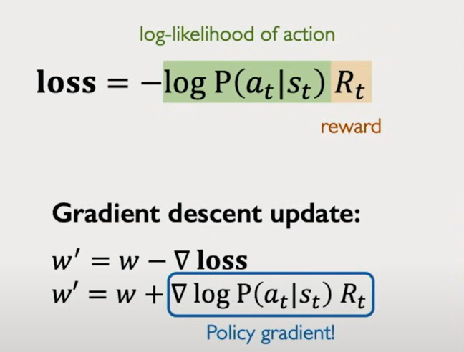
This form encourages the policy to:
- Boost log-probability for good actions (high Rt​)
- Reduce log-probability for bad actions (low or negative Rt​)

